**SAC ACTUM CENOTE EXCURSION**

**November 1, 2018**

The Sac Actun system, located in northeast Quintana Roo, Mexico, is among the most extensive underwater cave systems located along the Caribbean coast of the Yucatan Peninsula. The cave is composed of linear phreatic conduits that have two forms. The coastal sections of the Sac Actun system are characterized by low horizontal tunnels that form mazes paralleling the coast and rudimentary conduits broken by fracture-controlled rooms. Inland passages are fault/fracture controlled, have a linear, anastomotic configuration, and align perpendicular to the coast.

Access to the cave system is gained through cenotes which are the portals into the Yucatan underwater cave systems. The occurrence of drowned speleothems in many parts of the cave system, and sections of air-filled upper level passages are indicative of major fluctuations in sea level. The Sac Actun system is part of one of the most extensive and significant eogenetic karst aquifers in the world.

The development of the Sac Actun system, as well as the many other caves systems along the Yucatan Caribbean Coast is controlled by the coastal hydrologic regime, driven by glacio-eustatics, and influenced by stratigraphic and structural controls. The karstic permeability of the aquifer makes it and the Sac Actun system vulnerable to the anthropogenic impacts of increased population growth, quarries, and infrastructure development associated with the burgeoning tourist industry that dominates land use in the

region.

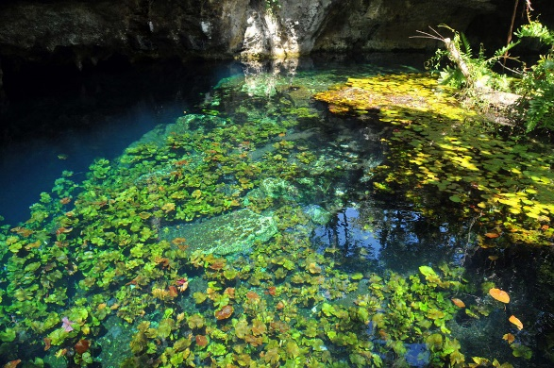 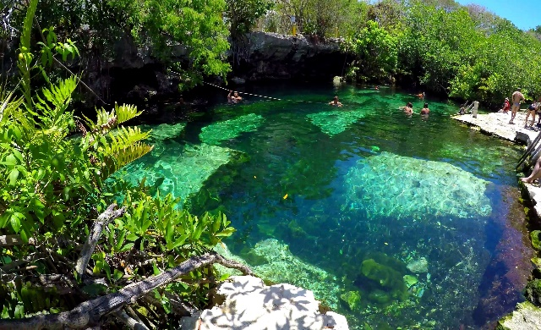

Driving from Sanara to Cenote: 45 minutes

Unit Style: Sprinters for 16 participants max

Capacity in Cenote: 12-15 pax at same time

Entrances: Every 15 minutes

Duration at Cenote: 1 hour approx

Itinerary from Cenote: From 11.00 a.m. to 5.00 p.m.

Last entrance is 3.30 p.m.

Price of the tour per person: $70 US Dlls. per person with snacks and drinks

Groups: 5 Groups of 15-16 people each

Not included: $12 US Dlls. for Neopreno Suite - per person

Gratuities for Drivers, staff and guides at Cenote



ITINERARIES



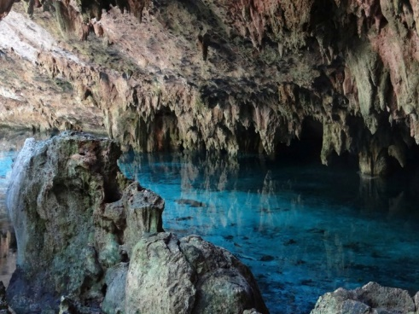

Recommended:

Bring towels from the hotel

Bring sun hat and comfortable clothing (wet shoes, shorts, t-shirt and extra clothing if getting wet)

Sun glasses, repellent and biodegradable suntan lotion

RESERVATION PROCEDURES

Alejandra Orozco, our main contact at Your Cancun DMC will send confirmation numbers once you have made your reservation. We need you to send complete name, how many guests are in your party, what group you want to be on and if you will need Neopreno suit. Once she has all this info, she will send you a paypal link with the total to cover. Alex information is below:

Alejandra Orozco

Sales Director

YOUR CANCUN DMC

[Alex.orozco@yourcancundmc.com](mailto:Alex.orozco@yourcancundmc.com)

011 52 – 998 275 32 78

We look forward to an unforgettable experience!!!